The reason for the modified equation:
The lowest book value was .4, and I wanted a positive number, and the first result was too small to really show the trend. But to avoid being accused of simple number manipulation, pure price vs. book and price vs. bookx4 (respectively) are also shown below.

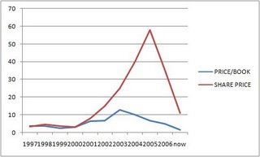
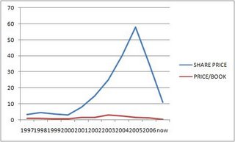

So you can see, the data is legitimate, I just wanted to highlight and exaggerate the trend.

